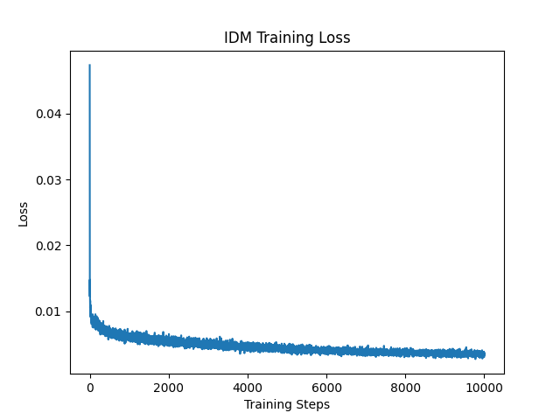Figure 1: IDM training loss for Ant-V2
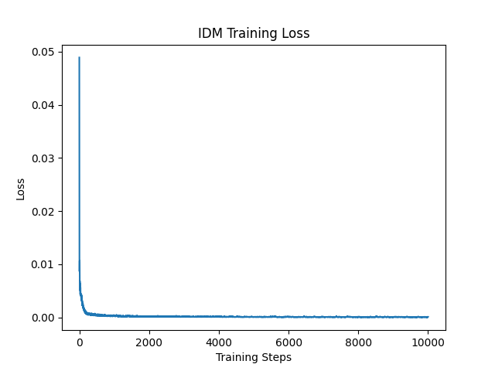Figure 2 IDM training loss for HalfCheetah-V2

